|  |  |  |
| --- | --- | --- |
| **Topic no** | **Topic name** | **Page no** |
| 01 | Introduction |  |
| 02 | Learning Kotlin |  |
|  | * learning process |  |
| 03 | Introduction to Android Studio and XML |  |
|  | * learning process |  |
| 04 | Project :Implementing basic data structure with kotlin and xml |  |
| 05 | Conclusion |  |

**Introduction:**

* **Purpose of the report:** This report is about learning about basic of android development with kotlin, xml, fundamental of android studio.
* **Motivation for learning Android development:** In this course the choice of project was independent I pick android development. Because of I find it interesting to learn it.And it is relevant to my course learning outcome.

**Learning Kotlin:**

* **Choosing Kotlin as my programming language for Android development**: Kotlin offers concise syntax, null safety, and seamless interoperability with Java, making it a compelling choice for Android development. Its support for coroutines simplifies asynchronous programming, while extension functions and immutable data structures promote cleaner and safer code. Backed by **strong tooling support from Google** and JetBrains, Kotlin's active community adoption and modern language features enhance developer productivity and code quality, cementing its position as a leading language for Android app development.
* **Learning process:**  For study kotlin I start to learn with the [documentation of kotlin](https://kotlinlang.org/docs/getting-started.html) and [tutorial.](https://www.youtube.com/playlist?list=PLQkwcJG4YTCRSQikwhtoApYs9ij_Hc5Z9)

In this processes I learn about-

* Variables
* Basic types
* Collections
* Control flow
* Functions
* Classes
* Null safety

**Introduction to Android Studio and XML:**

**Android Studio** stands as the quintessential Integrated Development Environment (IDE) for Android application development, offering an extensive array of tools meticulously designed to streamline the entire development lifecycle. As the official IDE sanctioned by Google, Android Studio provides developers with an integrated suite of features, including code editing, debugging, testing, and performance profiling, all finely attuned to the nuances of Android development. By consolidating these tools within a single environment, Android Studio enables developers to efficiently create, iterate, and optimize their Android applications with ease.

**XML (eXtensible Markup Language)** holds a central role in Android development, particularly in the realm of designing user interfaces through layout specifications. Android Studio boasts robust XML editing capabilities, allowing developers to craft layouts either through a visual interface using the Layout Editor or by directly manipulating XML code. These XML files delineate the structure and appearance of various UI components within an app, encompassing views, widgets, and containers.

In the Android development landscape, XML files adhere to a hierarchical structure, with each file corresponding to a specific UI component or configuration aspect of the application. Through XML attributes, developers specify a myriad of properties and behaviors for UI elements, spanning layout dimensions, text content, styling, and event handling. This declarative approach to UI design empowers developers to precisely define the visual and interactive aspects of their applications, fostering intuitive and engaging user experiences.

Mastering XML within the confines of Android Studio is indispensable for developers seeking to create polished and user-friendly Android applications. With its robust toolset and seamless integration with XML-based layout design, Android Studio empowers developers to translate their creative visions into tangible, high-quality applications that resonate with users across the Android ecosystem.

**Learning processes:** For learning these topic I follow the [official documentation of android Studio](https://developer.android.com/guide) also [fundamentals of android studio](https://www.youtube.com/playlist?list=PLQkwcJG4YTCTq1raTb5iMuxnEB06J1VHX) and [XML](https://www.youtube.com/playlist?list=PLQkwcJG4YTCTq1raTb5iMuxnEB06J1VHX).

***Project:* *Implementing basic data structure with kotlin and xml***

**Introduction:** this app will operate with the basic operation of data structure like array, stack ,queue( and further it will add as feature as the advance of data structure algorithm and operation.)

Instrument:

* Android studio
* Build in emulator (using Pixel 8 API 30) to operate app functionality

App implementation:

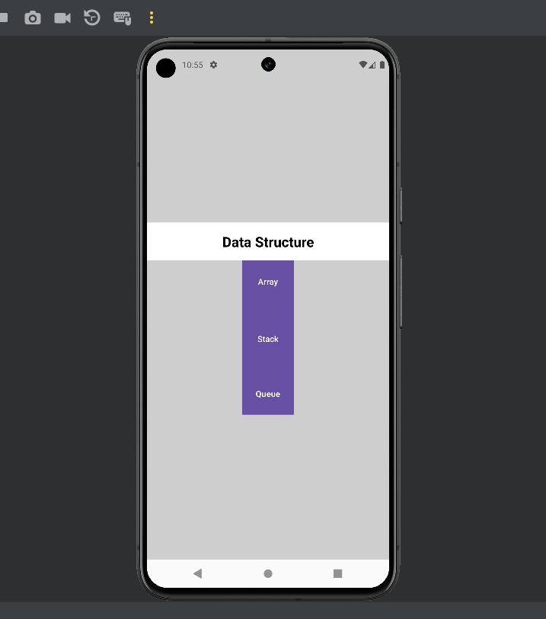**Home page**